**Installing Dependencies**

Pip install fbchat

We will be using [Dialogflow](https://dialogflow.com/) (Api.ai). We can install in using pip.

Pip install apiai

|  |
| --- |
|  |

 **Working With Dialogflow/Api.ai**

Go to [Dialogflow](https://dialogflow.com/) and click on console. Signup using your google account

Grant permissions and Accept the terms and conditions agreement.

Click on create new agent.

Give a name to your agent and click save.

Now click on the small talks tab on the left menu and enable it.

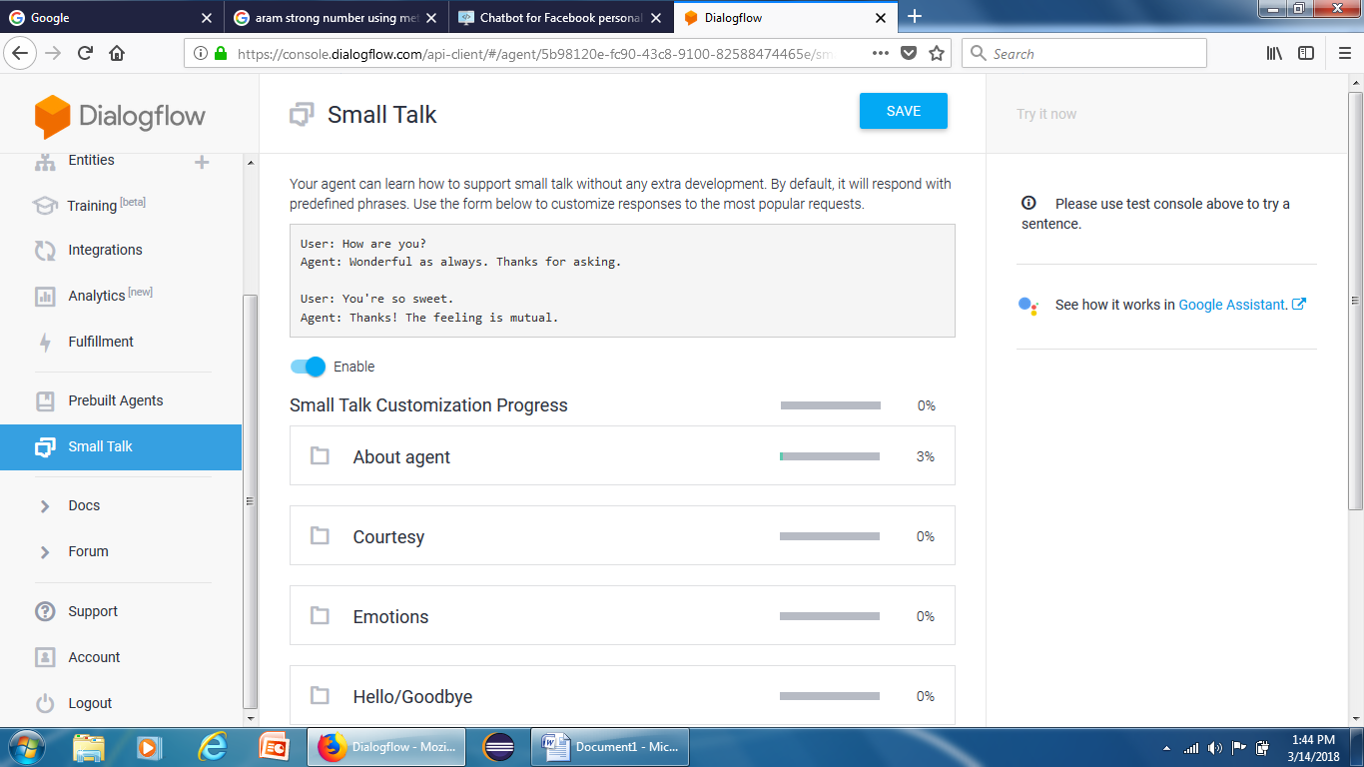

Give answers for all the question to train your agent and save it. You can give multiple answers for a single question.

Click on the gear icon, copy your **Client Access Token** from their and paste it in the code.

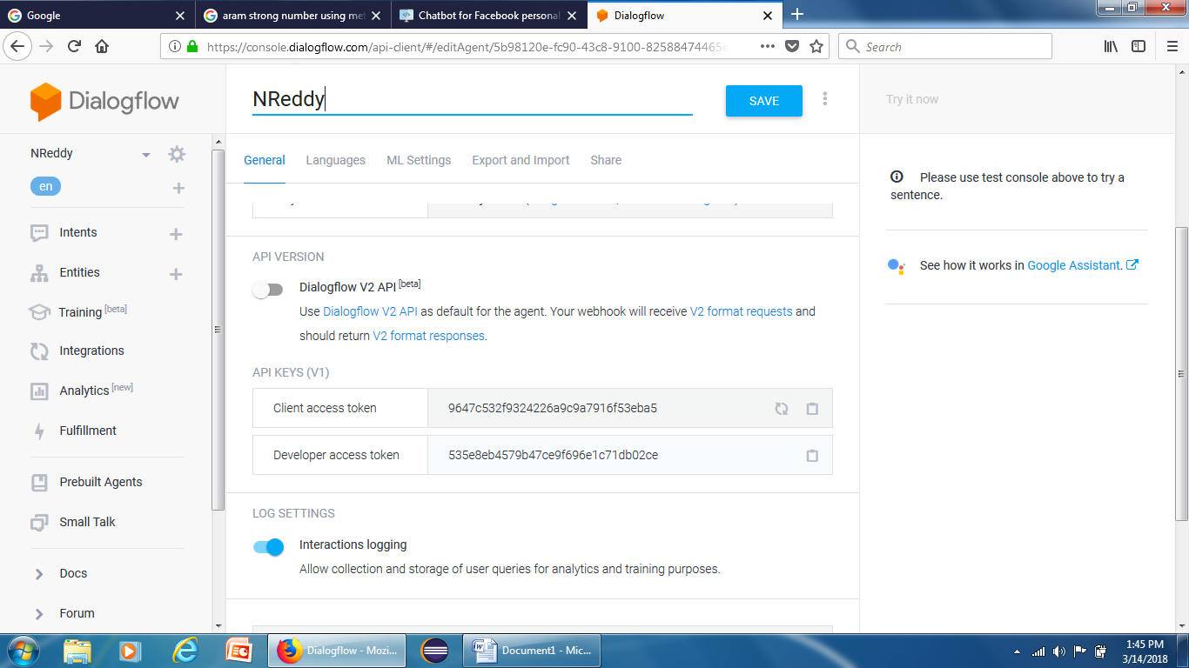

**Code Explanation**

We will add a new function in our existing code to establish a connection between our bot and dialogflow.

|  |  |
| --- | --- |
| 1  2  3  4  5  6 | # Connect to dialogflow       def apiaiCon(self):          self.CLIENT_ACCESS_TOKEN = "Your Client Access Token"          self.ai = apiai.ApiAI(self.CLIENT_ACCESS_TOKEN)          self.request = self.ai.text_request()          self.request.lang = 'de' #Default : English |

On receiving new message, we will request a reply for that message from dialogflow which will send us a json object in return.

|  |  |
| --- | --- |
| 1  2  3  4  5 | # Request query/reply for the msg received          self.request.query = msgText          # Get the response which is a json object          response = self.request.getresponse() |

We will convert the json object into a python list and store the reply in a variable **reply.**If you are using python 3.6 you can skip the decoding part.

|  |  |
| --- | --- |
| 1  2  3  4  5  6 | # Convert json obect to a list. For python 3.6 replace json.load(reader(response)) with json.load(response)  reader = codecs.getdecoder("utf-8")  obj = json.load(reader(response))  # Get reply from the list  reply = obj['result']['fulfillment']['speech'] |
|  |  |

and that’s it! You have a fully working chatbot for your personal Facebook profile

### How it works

We will login from a Facebook account using a script and wait and listen for new incoming messages. Once we receive a new message, we will get the text of that message, feed it into a trained model which will do the magic for us using natural language processing and machine learning and return a response. We will then send that response to the person who sent you the message on Facebook.

**Coding Explanation:**

We will start by creating a class which will **extend fbchat.Client**. In this class, we will **override** the method **onMessage()**. This method is triggered whenever you will receive a new message on Facebook. In this method we will mark the message as read by calling method **markAsRead().** The variable **thread_id** is the **id** of the person who sent you the message. Then we will print the Message, Sender’s profile id and the type of conversation (either a private message or group chat) onto the console. We will then reply the person who texted us with ‘Hello World’. The **send()** method takes 3 arguments, a **message_object,** the **id** of the person you want to send the message and **type** of chat. **Message_Object** contains information regarding the message which includes message text, emojis, media attachments etc. After we’ve sent ‘Hello World’, we will mark the message as delivered by calling the method **markAsDelivered().**In the next part we will use natural language processing and machine learning so that our bot can answers different questions instead of just saying hello world.